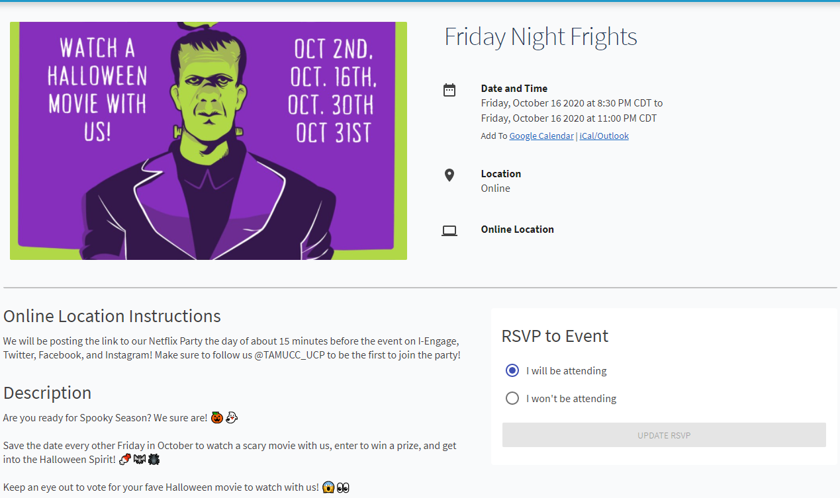

2 weeks ago, and today I attended or will be attending Friday night frights. I was not planning on join this event because I’m a wuss when it comes to Horror movies and games. But my girlfriend insisted we watched. It was quite the reversal of rolls because I was hiding behind her the entire time. I’m excited for whatever we will watch today… it wat I tell her. I’m not… haha. Yay for horror movies.